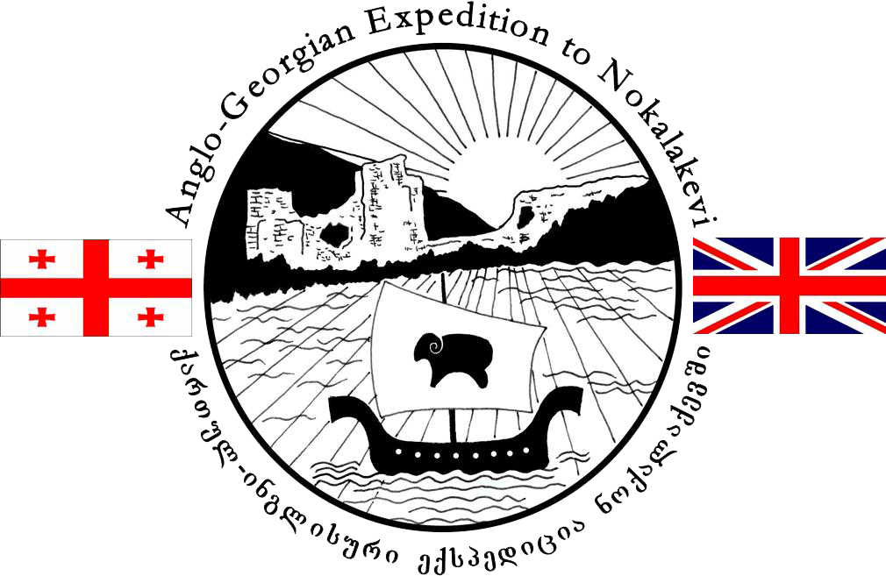
noqalaqevi
REGISTRATION FORM

Please complete this form carefully and return it to one of the directors of the Expedition, Ian Colvin, Paul Everill or Benjamin Neil.
Full Name |  |  |  |  |  |  |  |  |  | Date of Birth
Citizenship |  |  |  |  | Passport No. |  |  |  |  | Expiry Date
University |  |  |  |  |  |  |  |  |  | Year of Study
Resident (term time) Address |  |  |  |  | Permanent (or Holiday) Address |  |  |  |  | Next of Kin’s Address (inc. name)
Tel |  |  |  |  | Tel |  |  |  |  | Tel
Mobile |  |  |  |  | Mobile |  |  |  |  | Email
Email |  |  |  |  | Email |  |  |  |  | Relationship
Are you a trained first aider? |  |  |  |  |  |  |  | Is the qualification current?
Insurance details:
it is a booking condition that you must be covered by comprehensive travel insurance. Please take this insurance seriously, making certain you are covered from the day you pay, in case you need to cancel.
Insurance Company |  |  | Policy Number |  |  |  |  |  | 24hr Medical emergency telephone (provided by your insurers):
Do you have any special dietary requirements?
Do you have any known medical conditions or allergies?
It is possible to discuss this confidentially with one of the directors if you prefer

I have read and understood the latest advice from the British Foreign Office (and my own country’s where applicable) with respect to travel to Georgia, particularly with respect to the risks of crime (including kidnapping), terrorism and health. I understand that although we will take all possible precautions to identify and control risks, the Anglo-Georgian Expedition cannot provide absolute guarantees of safety with respect to circumstances beyond our control

I have read and understood the Risk Assessment and agree to abide by the advice and instructions of the project directors and supervisors with respect to working practice and all other aspects of conduct during the course of the project

I have made the project leader(s) aware of any relevant circumstances that may affect my participation in the project

I will check with my local GP or Travel clinic and obtain all relevant vaccinations well in advance of the expedition

Signed |  | Date

